MIDDLEWARE: Hardware and Software requirements-Netware connectivity-Types of Middleware

Client/Server software requirements
- 90 percent of information technology (IT) departments' budgets are spent maintaining and enhancing existing systems
- Business Process Reengineering (BPR) techniques help organizations achieve competitive advantage through substantive improvements in quality, customer service and costs
- BPR must be aligned with technology strategy to be effective.
- Organizations must use technology to enable the business change defined by the BPR

Factors Driving Demand for Application Software Development
- Strategic planning, development, and follow-on support for applications software is a vital,Expensive
- BPR and total quality management (TQM) programs demand software development and enhancements.
- A competitive market insists that companies demonstrate their value to a skeptical buyer through increasing the value of product and services.

Rising Technology Staff Costs
- technology personnel costs are rising much faster than inflation
- Many organizations find that technology professionals, in whom much organization specific application and technology knowledge has been invested, change jobs every three to five years
- must develop a continuous learning program

Pressure to Build Competitive Advantage by Delivering Systems Faster
- to build competitive advantage
- The application backlog is horrific
- 80 to 90 percent of the traditional host-based MIS shop's staff time is devoted to maintaining

Need to Improve Technology Professionals' Productivitiy
- New breed of software tools
- Companies need new, innovative mission-critical systems
  - to be built quickly, with a
  - highly productive, committed professional staff partnered with end-users during the requirements, design, and construction phases.

Need for Platform Migration and Reengineering of Existing Systems

Need for a Common Interface Across Platforms

Increase in Applications Development by Users

Client/Server Systems Development Methodology
SILC Phase | Major Activities
Systems Planning | Initiate systems planning
 | Gather data
 | Identify current situation
 | Describe existing systems
 | Define requirements
 | Analyze applications and data architectures
 | Analyze technology platforms
 | Prepare implementation plan
Project Initiation | Screen request
 | Identify relationship to long-range systems plan
 | Initiate project
 | Prepare plan for next phase
Architecture Definition | Gather data
 | Expand the requirements to the next level of detail
 | Conceptualize alternative solutions
 | Develop proposed conceptual architecture
 | Select specific products and vendors
Analysis | Gather data
 | Develop a logical model of the new application system
 | Define general information system requirements
 | Prepare external system design
Design | Perform preliminary design
 | Perform detailed design
 | Design system test
 | Design user aids
 | Design conversion system
Development | Set up the development environment
 | Code modules
 | Develop user aids
 | Conduct system test
Facilities Engineering | Gather data
 | Conduct site survey
 | Document facility requirements
 | Design data center
 | Plan site preparation
 | Prepare site
 | Plan hardware installation
 | Install and test hardware
Implementation | Develop contingency procedures
 | Develop maintenance and release procedures
 | Train system users
 | Ensure that production environment is ready
 | Convert existing data
 | Install application system
 | Support acceptance test
 | Provide warranty support
Post-implementation | Initiate support and maintenance
Support | services
 | Support hardware and communication configuration
 | Support software
 | Perform other project completion tasks as appropriate

Middleware

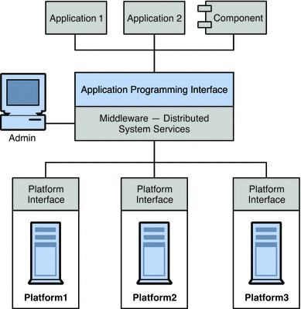

Easiest way to integrate heterogeneous components is not to recreate them as homogeneous elements but to provide a layer that allows them to communicate despite their differences

This layer, called middleware, allows software components (applications, enterprise java beans, servlets, and other components) that have been developed independently and that run on different networked platforms to interact with one another

Middleware can be grouped into the following categories:

Remote Procedure Call or RPC-based middleware, which allows procedures in one application to call procedures in remote applications as if they were local calls. The middleware implements a linking mechanism that locates remote procedures and makes these transparently available to a caller. Traditionally, this type of middleware handled procedure-based programs; it now also includes object-based components.

Object Request Broker or ORB-based middleware, which enables an application’s objects to be distributed and shared across heterogeneous networks.

Message Oriented Middleware or MOM-based middleware, which allows distributed applications to communicate and exchange data by sending and receiving messages.

All these models make it possible for one software component to affect the behavior of another component over a network.

They are different in that RPC- and ORB-based middleware create systems of tightly-coupled components, whereas MOM-based systems allow for a looser coupling of components.

In an RPC- or ORB-based system, when one procedure calls another, it must wait for the called procedure to return before it can do anything else.

In these synchronous messaging models, the middleware functions partly as a super-linker, locating the called procedure on a network and using network services to pass function or method parameters to the procedure and then to return results.

MOM-based systems allows communication to happen through the asynchronous exchange of messages

Types of Middleware

Message-oriented middleware

Message-oriented middleware (MOM) is middleware

where transactions or event notifications are delivered between disparate systems or components by way of messages,

often via an enterprise messaging system.

With MOM, messages sent to the client are collected and stored until they are acted upon, while the client continues with other processing.

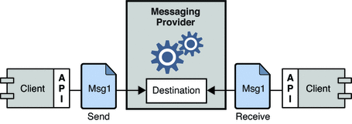

Combining RPC and MOM systems

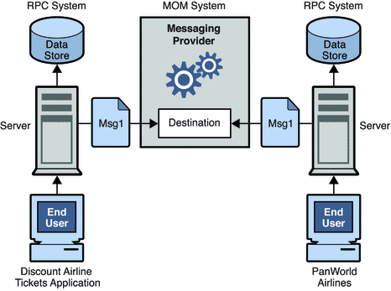

Enterprise messaging system

An enterprise messaging system is a type of middleware that facilitates message passing between disparate systems or components in standard formats,

often using XML, SOAP or web services.

As part of an enterprise messaging system, message broker software may queue, duplicate, translate and deliver messages to disparate systems or components in a messaging system.

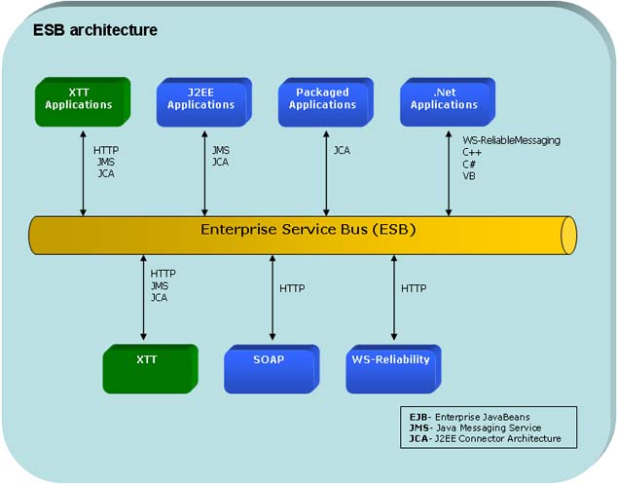

Typically uses an ESB now

Enterprise service bus

Enterprise service bus (ESB) is defined by the Burton Group [11] as "some type of integration middleware product that supports both message-oriented middleware and Web services".

Functional requirements of an ESB

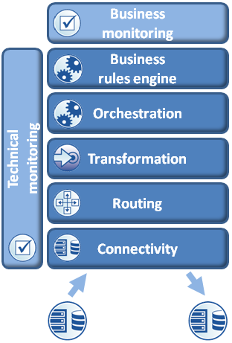

Intelligent middleware

[12] Intelligent Middleware (IMW) provides real-time intelligence and event management through intelligent agents.

The IMW manages the real-time processing of high volume sensor signals and turns these signals into intelligent and actionable business information.

The actionable information is then delivered in end-user power dashboards to individual users or is pushed to systems within or outside the enterprise.

It is able to support various heterogeneous types of hardware and software and provides an API for interfacing with external systems.

It should have a highly scalable, distributed architecture which embeds intelligence throughout the network to transform raw data systematically into actionable and relevant knowledge.

It can also be packaged with tools to view and manage operations and build advanced network applications most effectively.

Content-centric middleware

Content-centric middleware offers a simple provider-consumer abstraction through which applications can issue requests for uniquely identified content,

without worrying about where or how it is obtained.

Juno is one example, which allows applications to generate content requests associated with high-level delivery requirements.[13]

The middleware then adapts the underlying delivery to access the content from sources that are best suited to matching the requirements.

This is therefore similar to Publish/subscribe middleware, as well as the Content-centric networking paradigm.

Example: DDS (data distribution services)

Remote procedure call

Remote procedure call middleware enables a client to use services running on remote systems. The process can be synchronous or asynchronous.

Object request broker

With object request broker middleware, it is possible for applications to send objects and request services in an object-oriented system.

SQL-oriented data access

SQL-oriented Data Access is middleware between applications and database servers.

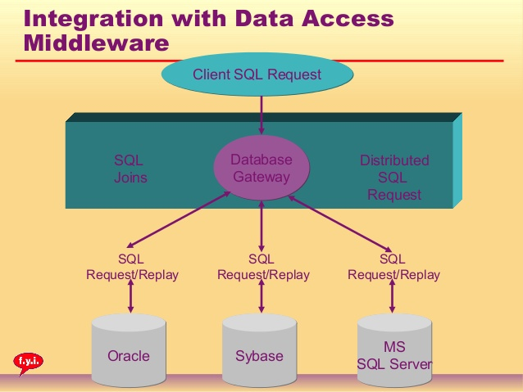

Embedded middleware

Embedded middleware provides communication services and software/firmware integration interface that operates between embedded applications, the embedded operating system, and external applications.

Transaction processing monitors – provides tools and an environment to develop and deploy distributed applications Programming controls most middleware facilities other than transactions

Application servers – software installed on a computer to facilitate the serving (running) of other applications. Programming controls most middleware facilities

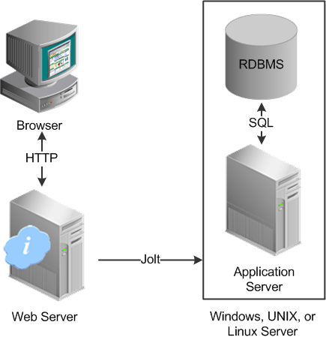

SQL integration/interoperability: Single Vendor option

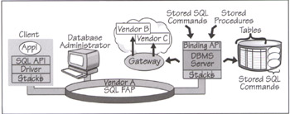

typical single-vendor middleware solution currently provides

A vendor-proprietary SQL API that works on a multiplicity of client platforms

Most vendors support DOS, Windows, and OS/2 clients; quite a few also support Macintosh and some Unix variants

A vendor-proprietary SQL driver
- This is a thin client run-time element that accepts the API calls, formats an SQL message, and handles the exchanges with the server.
- The format of the SQL message and the handshake are known affectionately as the FAP, which stands for Format and Protocols. The SQL FAPs are typically vendor-defined.

FAP support for multiple protocol stacks.
- most vendors now support multiple protocol stacks.
- Some vendors bundle the stacks with their drivers; others support a common transport interface (like Sockets or Named Pipes) and require that you provide your own stacks
- At the server side, the vendor typically provides "listeners" for the different stacks.
- However, some vendors provide their own internal protocol gateways—for example, Oracle on Unix translate IPX/SPX packets to TCP/IP o the server side.

Gateways to other vendor databases
- Most vendor-supplied database gateways only provide an intersection of the features supported by the two databases—the least common denominator.
- This means that most vendor-supplied database gateways only support dynamic SQL.
- They are only good for simple data extracts and queries—not for transaction processing.

Client/Server database administration tools.

Front-end graphical application development and query tools

SQL integration/interoperability: multi vendor option

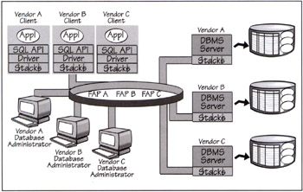

Interoperability between N vendor databases ends up being an N² problem.

Challenges:
- Different SQL APIs
- Multiple database drivers
- Multiple FAPs and no solid interoperability
- Multiple administration tools
- Worse: federated database joins, federated commits, or concurrent access to federated data

Middleware Solution #1: The Common SQL Interface
- Choose one SQL API and standardize on
- Multiple drivers are still required
- Multiple managing stations and multiple FAPs are still required.

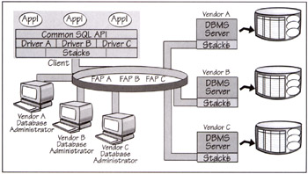

Middleware Solution #2: The Open SQL Gateway

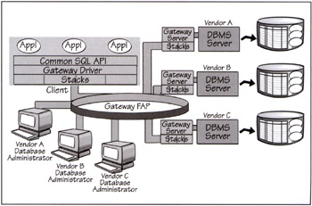

Middleware Solution #3: Federated
- To create a federated SQL environment that provides the same level of completeness as the single vendor implementation
- Remove the gateway catchers, which improves server performance, reduces cost, and simplifies maintenance.
- Create a single database administration interface

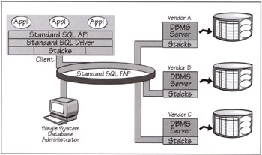

To eliminate the gateway catchers, the common FAP must either support a superset of all the SQL dialects or it must tolerate native SQL dialects (meaning that it must allow pass-throughs). The SQL vendors must also agree to replace their own private FAPs with the common FAP

Network Operating System (NOS) middleware

Goal: to provide a single system image across large networks

NOSs are evolving from being a collection of independent workstations, able to communicate via a shared file system, to becoming real distributed computing environments that make the network transparent to users

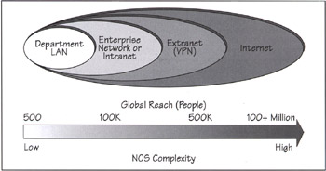

Transparencies desired:

Location transparency—
- You should not have to be aware of the location of a resource.
- Users should not have to include the location information in the resource's name.
- For example, \\Machine\directory\file surfaces the name of the server machine. This is a transparency violation.

Namespace transparency—

Able to use the same naming conventions (and namespace) to locate any resource on the network. Universal namespace is shown below

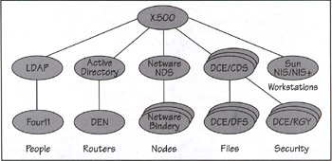

Logon transparency—You should be able to provide a single password (or authentication) that works on all servers and for all services on the network

Replication transparency—You should not be able to tell how many copies of a resource exist.

Local/remote access transparency—You should be able to work with any resource on the network as if it were on the local machine.

Distributed time transparency—You should not see any time differences across servers.The NOS must synchronize the clocks on all servers.

Failure transparency—You must be shielded from network failures. The NOS must handle retries and session reconnects. It must also provide some levels of service redundancy for fault-tolerance.

Administration transparency—You should only have to deal with a single-system management interface. The NOS must be integrated with the local management services.

NOS: Extending the local OS’ reach

Goal: Practically anything that can be done on a local OS can be done remotely and transparently.

- The NOS allows applications written for the local OS to become networked without changing a line of code
- Most NOSs allow clients that run on different OSs (such as DOS, Windows 98, Mac, and Unix) to share files and other devices
- the DCE Distributed File Service (DFS) provides a single-image file system that can be distributed across a group of file servers
- The DFS file naming scheme is location-independent.
- Each file has a unique identifier that is consistent across the network
- Files use the DCE global namespace just like the rest of the network resources. And the file system is integrated with the DCE security mechanisms.

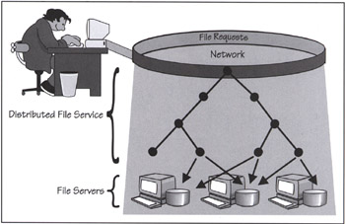
- DFS provides a Local File System (LFS) with many advanced features, including replication facilities that make the file system highly available

Global Directory Services
- The state of a client/server system is always in flux.
- Users join and leave the network.
- Services can be added and moved around at will. Data is always being created and moved around
- Ideally, a distributed directory should provide a single image that can be used by all network applications—including e-mail, system management, network inventory, file services, RPCs, distributed objects, databases, authentication, and security.

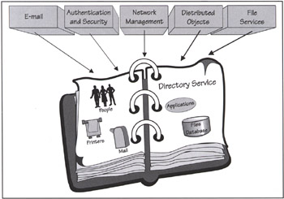
- A directory lets you search its objects by attribute.
- A schema describes the types of objects a directory may contain; it also describes the attributes—both mandatory and optional—associated with an object type.
- Modern NOS directories have APIs and user interfaces that allow programs (or humans) to locate entities on the network by querying on the name or attributes.

Federated Directories—Creating a Unified Namespace.

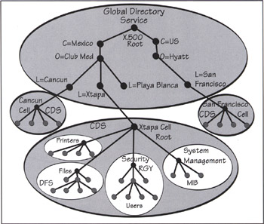

Typically, a directory maintains a master copy and read-only shadow replicas.

Two types of synchronization schemes are used to refresh the replicas:
- Direct replication causes any update to the master to be immediately shadowed on all replicas.
- Skulking causes a periodic propagation (for example, once a day) to all the replicas of all changes made on the master.

NetWare Directory Service (NDS)—now supports multi-master updates.

In contrast, LDAP (Lightweight Directory Access Protocol)is currently a single-master technology

How Do You Interface to These Directories?
- Directory-specific APIs and class libraries
  - These provide interfaces that are tightly-coupled to a product such as Novell and Banyan provide APIs to their respective directories.
- LDAP and X.500 APIs
  - These are the standards-based interfaces defined by the IETF, X/Open, and the CCITT for the LDAP and X.500 directories
- Java classes
  - The JavaSoft-defined Java Naming and Directory Interface (JNDI) provides a set of generic Java classes that let you interface to a variety of directory services—such as LDAP, NDS, CORBA Naming, and NIS
- Distributed object interfaces.
  - ORB-based interfaces that let you talk to directory servers across ORBs
  - Typically, these interfaces let you pick your language, directory service, and platform
  - Example CORBA naming service (directory-neutral, language-neutral, and platform-neutral)
  - In the COM parallel universe, Microsoft defines the Active Directory Service Interface (ADSI). It is a directory-neutral and language-neutral interface for COM+ objects
- Meta-directory services and scripts
  - Meta-directories are glue products—from companies like Zoomit, NetVision, and WorldTalk—that synchronize data in existing directories via scripts.

X.500 and LDAP
- In the old days, a directory service was tied to a single application such as e-mail or to a specific operating system, such as NT domains.
- In contrast, a universal directory must be totally independent of both applications and NOSs.
- The original industry standard for universal directories was CCITT's X.500.
- However, X.500 proved to be too bulky and overly complicated.
- Today, the industry's new Esperanto for directories is LDAP—a downsized version of the original X.500.

X.500

The X.500 architecture is based on a replicated distributed database

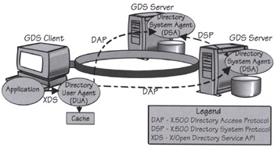
- Programs can access the directory services using the X/Open Directory Service (XDS) APIs
- The XDS APIs allow programs to read, compare, update, add, and remove directory entries; list directories; and search for entries based on attributes.
- use the X/Open Management (XOM) API for defining and navigating through the information objects that are in the directory.
- Each object in an X.500 directory belongs to a class
  - A class can be derived from other classes. XOM provides an API for defining object classes and their attributes. XOM APIs also define basic data types such as string.
- Protocols:
  - The X.500 client component (the Directory User Agent (DUA))
  - and server component (the Directory System Agent (DSA))
- communicate using the Directory Access Protocol (DAP).
- Servers talk to each other using the Directory System Protocol (DSP).
- The DAP and DSP formats and protocols are defined in the X.500 standard and provide worldwide interoperability among directory services.
- The X.500 standard was written to be on top of the OSI communication protocol
- X.500 is implemented—fully of partially—in a number of products—including DCE, Microsoft Exchange, Lotus Notes, and the NetWare Directory Service

These partial implementations of X.500 protocol did not interoperate, which was a big problem. Most vendors found the entire X.500 protocol too bulky to implement

So the Light-weight Distributed Access Protocol (LDAP) was born.

LDAP
- originally designed by Netscape with help from researchers at the University of Michigan to provide a simplified version of the X.500 DAP that could also run on TCP/IP networks
- The idea was to provide a lightweight PC client implementation that could access X.500 directory servers over the Internet.
- LDAP became very popular and is now supported by all major directories
- LDAP uses the X.500 naming scheme and namespace,
- LDAP objects are named collections of named attributes.
- Each object has a distinguished name (dn) and belongs to an objectclass that identifies its object type (or schema). Attributes have common mnemonics
- some examples
  - Objectclass = object type
  - dn = distinguished name
  - cn = common name
  - mail = e-mail
  - c = country
  - o = organization
  - ou = organization unit
- objectclass = employee
- dn = Jeri Edwards, o = BEA Systems, ou = strategy, c = US
- mail =<jlstedwards@bsasys.com>
- LDAP lets you issue queries using a URL-like syntax. For example:
  - ldap://ldap,beasys.com/o = BEA Systems, ou = Java, c = US?

This hypothetical query returns all the Java programmers working for BEA Systems in the U.S.

How to ask

What is the telephone number of BEA Systems' strategy department?

What is Jeri Edwards' fax number?

Who are the developers working on the XYZ project?

LDAP v3
- Scheme discovery lets a client query an LDAP server to discover the object types it supports; it can also discover the attributes associated with a given type.
- Dynamically extensible schemes let a client define at run time new types of objects to be stored on a server. The client does this using LDAP v3's new extensibleObject class.
- Enhanced security includes LDAP over secure sockets and simple authentication.
- Intelligent referrals let a server refer a query to another server. This creates the illusion of a single directory, even if the data is scattered across multiple servers.
- Support for international character sets lets users deploy and search directories using their native language.

RPC, Messaging, and Peer-to-Peer:
- Client/server applications are split across address spaces, physical machines, networks, and operating systems.
- The purpose of the NOS is to make distributed computing transparent. This means it must create an environment that hides the nastiness of dealing with communication protocols, networks, and stacks.
- All NOSs offer peer-to-peer interfaces that let applications communicate using close-to-the-wire send/receive semantics.
- Most NOSs provide some form of Remote Procedure Call (RPC) middleware that hides "the wire" and makes any server on the network appear to be one function call away.
- An alternative type of model—message queuing, or simply Message-Oriented Middleware (MOM)
- It turns out that messaging is incredibly helpful in situations where you do not want the clients and servers to be tightly synchronized.

What's a Stack Anyway?

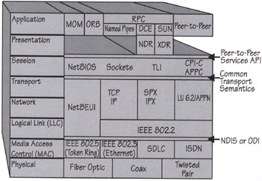
- Communications software vendors have tackled the problem of network complexity by breaking down complex protocols into layers.
- Each layer builds on top of the service provided by the layers below it. Eventually, you get a stack of layers that looks like a birthday cake.
- Vendors sell their communication products as stack offerings that are architected to work together.
- In theory, each stack layer has a well-defined set of APIs and protocols so that it should be possible to mix-and-match different vendor offerings within the same stack.
- The lowest layer of communication software belongs to the device drivers that provide an interface to several types of communication hardware adapters.
- The bottom of the stacks sits on top of the device drivers. The top of the stacks sits right below the NOS. The stacks and NOS are simply divisions that help us create a survival map
- At the lower layers, they interface to the hardware using the physical Media Access Control (MAC) protocols
- The Logical Link Control (LLC) provides a common interface to the MACs and a reliable link service for transmitting communication packets between two nodes
- The OSI link layer combines the LLC and MAC functions. On top of this layer is the network layer that allows packets to be routed across multiple networks
- The transport layer sits on top of the network layer and provides some form of reliable end-to-end delivery service

Peer-to-Peer Communications
- Most early client/server applications were implemented using low-level, conversational, peer-to-peer protocols—such as sockets, TLI, CPIC/APPC, NetBIOS, and Named Pipes
- programmers are now using RPCs, MOMs, and ORBs, which provide higher levels of abstraction
- So the conversational protocols should only be used by very demanding user applications or system-level software.
- The term "peer-to-peer" indicates that the two sides of a communication link use the same protocol interface to conduct a networked conversation.
  - Any computer can initiate a conversation with any other computer.
  - The protocol is symmetrical, and it is sometimes called "program-to-program."
  - The peer-to-peer interface tends to be "close to the wire" in the sense that it does not fully mask the underlying network from the programmer.
  - For example, the interface will surface transmission timeouts, race conditions, and network errors, and then leave it to the programmer to handle.

Sockets

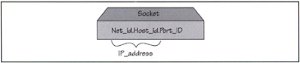

- The three most popular socket types are stream, datagram, and raw.
- Stream and datagram sockets interface to the TCP and UDP protocols, and raw sockets interface to the IP protocol

NetBIOS and NetBEUI

- NetBIOS is the premier protocol for LAN-based, program-to-program communications. Introduced by IBM and Sytek in 1984 for the IBM PC Network,
- NetBIOS now runs with almost no changes on every LAN.
- NetBIOS is used as an interface to a variety of stacks—including IBM/Microsoft LANs (NetBEUI), TCP/IP XNS, Vines, OSI, and IPX/SPX.
- Support for a NetBIOS platform exists on a multiplicity of operating system environments
- NetBEUI is the protocol stack that comes with IBM and Microsoft LAN products—including Windows for Workgroups, NT, LAN Manager, Windows 95/98, and OS/2 Warp
- NetBEUI offers powerful datagram and connection-oriented services.
- It also offers a dynamic naming service based on discovery protocols.
- NetBEUI's main weakness is the lack of a network layer.
- Its other weakness is the lack of security.
- The broadcast mechanism, used to dynamically "discover" names, can be a liability on an unsecured network where it's not a good idea to expose names.
- Broadcasting names also causes unwanted traffic on the network.
- Luckily, most bridges and routers have ways to filter the discovery packets and block them from propagating to other networks.

Named Pipes
- Named Pipes provide highly reliable, two-way communications between clients and a server. They provide a file-like programming API that abstracts a session-based two-way exchange of data.
- Using Named Pipes, processes can exchange data as if they were writing to, or reading from, a sequential file.
- Named Pipes are especially suitable for implementing server programs that require many-to-one pipelines.
- A server application can set up a pipeline where the receiving end of the pipe can exchange data with several client processes.
- Then it lets Named Pipes handle all the scheduling and synchronization issues.
- Advantage is that named pipes part of the base interprocess communications service.
- The Named Pipes interface is identical, whether the processes are running on an individual machine or distributed across the network.

The "New" SNA: APPC, APPN, and CPI-C
- From IBM on top of SNA
- Common Programming Interface for Communication's (CPI-C) builds on top of APPC and masks its complexities and irregularities
- Advanced Peer-to-Peer Network (APPN) is the network infrastructure responsible for this "true distribution."
- Writing to the CPI-C API allows you to port your programs to all SNA platforms

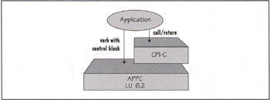

Remote Procedure Call (RPC)
- An essential problem is that RPCs are not procedure calls at all; they are truly process invocations.
- The invoked program runs across the wire in a different resource domain.
- RPCs hide the intricacies of the network by using the ordinary procedure call mechanism familiar to every programmer.
- A client process calls a function on a remote server and suspends itself until it gets back the results.
- Parameters are passed like in any ordinary procedure.
- The RPC, like an ordinary procedure, is synchronous.
  - The process (or thread) that issues the call waits until it gets the results.
- Under the covers, the RPC run-time software collects values for the parameters, forms a message, and sends it to the remote server.
- The server receives the request, unpacks the parameters, calls the procedure, and sends the reply back to the client.

Challenges in NOS:

How are the server functions located and started?

How are parameters defined and passed between the client and the server?

How are failures handled?

How is security handled by the RPC?

How does the client find its server?

How is data representation across systems handled?

The Mechanics of an RPC Stub Compiler

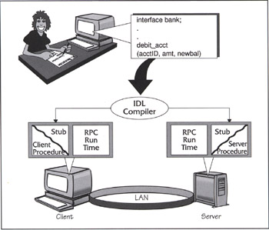

Getting a Seat for a Madonna Concert Using RPCs.

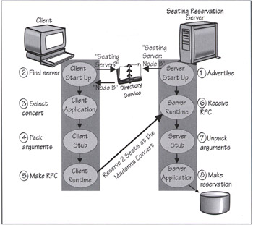

Every DAD needs a MOM

DAD – Distributed Application Development

MOM – Message Oriented Middleware

- MOM is a key piece of middleware that is absolutely essential for a class of client/server products
- If your application can tolerate a certain level of time-independent responses, MOM provides the easiest path for creating inter-enterprise client/server systems.
- MOM allows general-purpose messages to be exchanged in a client/server system using message queues.
- Applications communicate over networks by simply putting messages in queues and getting messages from queues
- MOM's messaging and queuing allow clients and servers to communicate across a network without being linked by a private, dedicated, logical connection
- MOM-enabled programs do not talk to each other directly, so either program can be busy, unavailable, or simply not running at the same time.
- A program can decide when it wants to retrieve a message off its queue
- Messaging queues are very versatile. You can use them to create one-to-many or many-to-one relationships

MOM: Two-way Message Queuing.

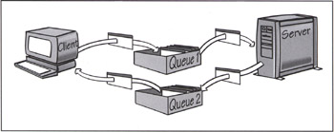

MOM: Save Your Messages Until You Get to a Server.

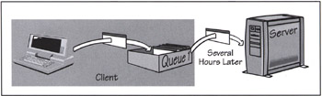

MOM: Many-to-Many Messaging via Queues.

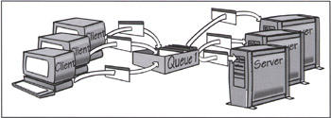
- Most MOM messaging products make available a simple API set that runs on multiple operating system platforms
- Most also provide persistent (logged on disk) and non-persistent (in memory) message queues.
- Persistent messages are slower, but they can be recovered in case of power failures after a system restart. In both cases, messages can be either copied or removed from a queue.
- A message queue can be local to the machine or remote.
- System administrators can usually specify the number of messages a queue can hold and the maximum message size.

Mom Versus RPC

Comparing the RPC and messaging paradigms is like doing business via a telephone call versus exchanging letters or faxes

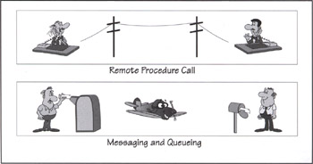

Messaging is, of course, more flexible, loosely-coupled, and time-tolerant than RPC.

Messaging does free clients from being synchronized to their servers

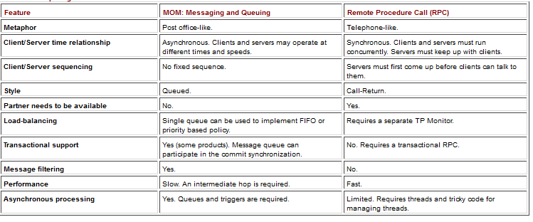

Publish and Subscribe?

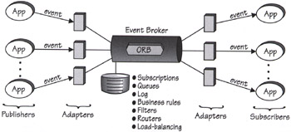

DCE: The Enterprise NOS

- The Distributed Computing Enviroment (DCE) from the Open Software Foundation (OSF
- creates an open Enterprise/NOS environment that spans multiple architectures, protocols, and operating systems.
- DCE provides key distributed technologies, including a remote procedure call, a distributed naming service, a time synchronization service, a distributed file system, a network security service, and a threads package

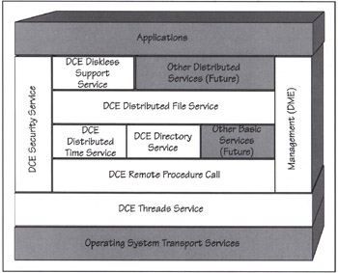
- DCE allows a client to interoperate with one or more server processes on other computing platforms, even when they are from different vendors with different operating systems.
- DCE provides an integrated approach to security, naming, and interprocess communications.

DCE RPC
- The DCE RPC initially came from HP
- DCE provides an Interface Definition Language (IDL) and compiler that facilitate the creation of RPCs.
- The IDL compiler creates portable C code stubs for both the client and server sides of an application.
- The stubs are compiled and linked to the RPC run-time library, which is responsible for
  - finding servers in a distributed system,
  - performing the message exchanges,
  - packing and unpacking message parameters, and
  - processing any errors that occur.
- DCE RPC can be integrated with the DCE security and naming services.
  - This integration makes it possible to authenticate each procedure call and to dynamically locate servers at run time.
- Servers can concurrently service RPCs using threads.
- The RPC mechanism provides protocol and network independence.

DCE: Distributed Naming Services
- Based on X.500
- The DCE naming services
  - allow resources such as programs, servers, files, disks, or print queues to be identified by user-oriented names
  - in a special-purpose distributed database that describes the objects of interest
  - Object names are independent of their location on the network.
- DCE divides the distributed environment into administrative units (or domains) called cells.
  - DCE cell is a combination of client and server workstations.
  - The cell's domain is defined by the customer.
  - A cell usually consists of the set of machines used by one or more groups working on related tasks.
  - The cell size is dictated only by how easy it is to administer.
  - At a minimum, a DCE cell must have one cell directory server and one security server.
- 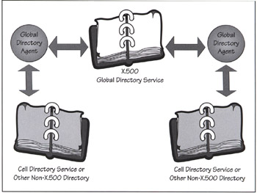

DCE: Distributed Time Service
- a mechanism for synchronizing each computer in the network to a recognized time standard.
- The DCE Time Service provides APIs for manipulating timestamps and for obtaining universal time from public sources such as the Traconex/PSTI radio clock.
- DCE requires at least three Time Servers; one (or more) must be connected to an External Time Provider
- The Time Servers periodically query one another to adjust their clocks.
- The External Time Provider may be a hardware device that receives time from a radio or a telephone source.
- DCE uses the UTC standard, which keeps track of time elapsed since the beginning of the Gregorian calendar—October 15, 1582

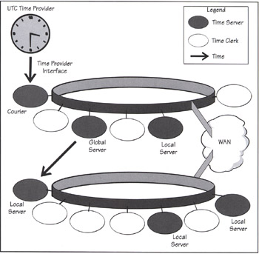

DCE: Distributed Security Services
- OSF adopted MIT's Kerberos authentication system and enhanced it with some HP security features.
  - based on total mutual distrust
  - The Kerberos monster consists of three "heads," all residing on the same secured server: the Authentication Server, Security Database, and Privilege Server
- DCE's network security services provide authentication, authorization, and user account management.
- The DCE security server is a physically secured server that stores security-related information such as names and associated passwords.
  - The security agent works with the authenticated RPC to provide secure access to all the DCE services
- The RPC mechanism hides all the complexity of the security system from the user.
  - It obtains the tickets, provides encryption when needed,
  - and performs authenticated checksums if the policy requires it.

- CE supports authorization through Access Control Lists (ACLs).
  - Each DCE implementation that uses ACLs must implement an ACL manager that controls access to services and resources managed by it

Distributed File System (DFS)
- The DCE Distributed File System (DFS) provides a uniform namespace, file location transparency, and high availability.
- DFS is log-based and thus offers the advantage of a fast restart and recovery after a server crash.
- Files and directories can be replicated (invisibly) on multiple servers for high availability.
- A cache-consistency protocol allows a file to be changed in a cache.
- The changes are automatically propagated to all other caches where the file is used, as well as on the disk that owns the file
- DFS provides a single-image file system that can be distributed across a group of file servers.

Threads
- OSF chose the Concert Multithread Architecture (CMA) from Digital
- This portable thread package runs in the user space and includes small wrapper routines to translate calls to a native kernel-based thread package (like NT or Mach threads).
- Threads are an essential component of client/server applications and are used by the other DCE components

The Internet as a NOS

Web Security

Encryption, Authentication, Firewalls, Non-repudiation

SSL (now TLS)
- As the name implies, Secure Sockets Layer (SSL) is a secured socket connection.
- Today, all commercial browsers and Web servers support SSL; it is the standard for authentication and encryption between Web browsers and servers.
- SSL also verifies that the content of the message hasn't been altered.
- SSL implements a security-enhanced version of sockets that provides transaction security at the transport level.
- SSL provides an unobtrusive security layer between the TCP/IP transport and sockets.
- In other words, SSL provides a secured communications link without involving the applications that invoke it; for example, the existence of SSL is transparent to e-mail or HTTP.
- HTTP servers that implement SSL must run on socket port 443 instead of the standard 80; it has become a common practice for firewall vendors to leave this port open.

The SSL protocol provides:

1) private client/server interactions using encryption,

2) server authentication, and

3) reliable client/server exchanges via message integrity checks that detect tampering.

When a client and server first start communicating, they agree on an SSL protocol version, select the cryptographic algorithms, optionally authenticate each other, and use public-key encryption techniques to generate shared secrets.
- The SSL handshake protocol must first be completed before an application can transmit or receive its first byte of data.
- The handshake protocol is like a dance that allows the client and server to authenticate each other and to negotiate an encryption algorithm.
- Typically, the browser needs to ensure that the server is using a valid certificate.
- This is how you protect yourself against rogue server impersonators.
- Servers can also use SSL to verify a client's credentials (or certificate).
- An SSL session may include multiple secure connections;
- in addition, you can have multiple simultaneous sessions.
- The encryption established between a client and a server remains valid over the multiple connections.
- SSL uses public key authentication and encryption technology developed by RSA Data Security

S-HTTP
- S-HTTP is a security-enhanced variant of the Internet's Hypertext Transport Protocol (HTTP) that was developed by EIT.
- S-HTTP adds application-level encryption and security on top of ordinary sockets-based communications. The client and server communicate over an ordinary HTTP session and then negotiate their security requirements; they use a MIME-like protocol to encrypt the contents of their messages.

S-HTTP provides the following security checks:

1) it authenticates both clients and servers,

2) it checks for server certificate revocations,

3) it supports; certificate chaining and certificate hierarchies,

4) it supports digital signatures that attest to a message's authenticity,

5) it allows an application to negotiate the security levels it needs, and

6) it provides secured communications through existing corporate firewalls.

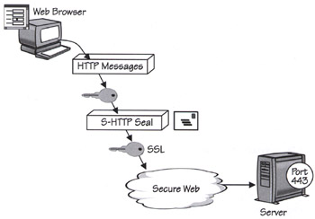

IPSec, Firewall, intranet, extranet and VPN - self study

Client/Server Application Development Tools

Development model that breaks the tool market around five axes

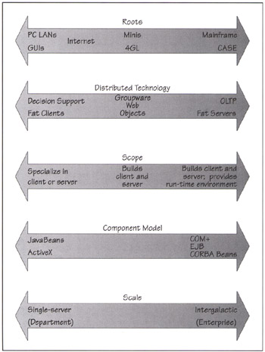

Characteristics of an ideal tool:

A visual place-builder for the first tier-ActiveX, Java Bean, Applet

A business-object builder for the second tier – ORB, CORBA, JAVA RMI, EJB

Frameworks that encapsulate the third tier- DBMSs, groupware, TP Monitors, MOM, ERP systems, e-mail, LDAP directories, and workflow

A visual environment for assembling components: To associate a client event in the first tier with a CORBA or COM+ method invocation on a business object in the second tier. Ex: CORBA IDL and Interface Repository

A component repository: A shared repository of reusable components, places, and server objects. The repository must, of course, provide check-in/check-out facilities and other such features. Ex: CORBA object server and interface repository.

Client/Server Application Design

Rapid Prototyping Is Essential

From Prototype To Working System

Understand the business process, Design the visual place, Define the components or business objects, Work on the detailed object views, Develop dry-run scenarios, Walk through a use-case system scenario, Identify transaction sources, Identify transaction sources, Publish the interfaces for the middle-tier server objects, Develop your code one business object at a time, Move from prototype to working system

Multi-Tier Computing:

Overview

Large distributed client/server computing architecture is viewed in terms of tiers.
- A tier is a logical partition of the separation of concerns in the system.
- Each tier is assigned its unique responsibility in the system.
- We view each tier as logically separated from one another.
- Each tier is loosely coupled with the adjacent tier.
- We represent the whole system as a stack of tiers:

Multitiered System Software Architecture (Java Enterprise Application Architecture)

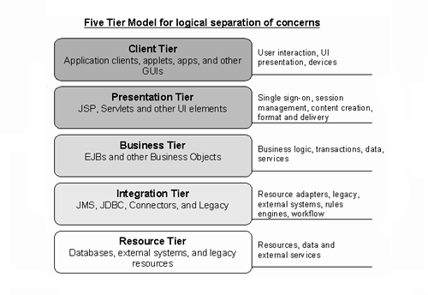

Client Tier
- This tier represents all device or system clients accessing the system or the application.
- A client can be a Web browser, a Java or other application, a Java applet, a WAP phone, a network application, or some device introduced in the future.
- It could even be a batch process.

Presentation Tier
- This tier encapsulates all presentation logic required to service the clients that access the system.
- The presentation tier
  - intercepts the client requests,
  - provides single sign-on,
  - conducts session management,
  - controls access to business services,
  - constructs the responses, and
  - delivers the responses to the client.
- Servlets and JSP reside in this tier.
- Note that servlets and JSP are not themselves UI elements, but they produce UI elements.

Business Tier
- This tier provides the business services required by the application clients.
- The tier contains the business data and business logic.
- Typically, most business processing for the application is centralized into this tier.
- It is possible that, due to legacy systems, some business processing may occur in the resource tier.
- Enterprise bean components are the usual and preferred solution for implementing the business objects in the business tier.

Integration Tier
- This tier is responsible for communicating with external resources and systems such as data stores and legacy applications.
- The business tier is coupled with the integration tier whenever the business objects require data or services that reside in the resource tier.
- The components in this tier can use JDBC, J2EE connector technology, or some proprietary middleware to work with the resource tier.

Resource Tier
- This is the tier that contains the business data and external resources
  - such as mainframes and legacy systems,
  - business-to-business (B2B) integration systems, and
  - services such as credit card authorization.

Tier interactions

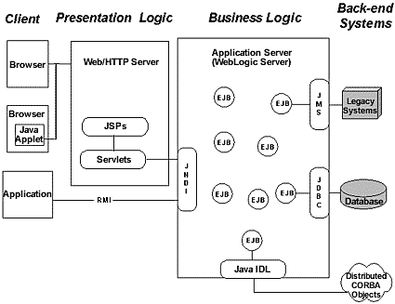

Merits and demerits

1 Tier Architecture
Advantages | Disadvantages
Easy to implement and optimize performance. | Do not support remote/ distributed access for data resources.
Do not have compatibility or Context switching issues. | The cost of deployment is less.eg-development and management cost.
The cost of deployment is less.eg-development and management cost. | Monolithic manner of the code causes higher maintenance.
 | The cost of the central mainframe is high.

2-tier Architecture
Advantages | Disadvantages
Applications can be easily developed due to simplicity. | Heterogeneous environments/Business environments with rapidly changing rules and regulations are not suitable, since the database server has to handle the business logic which slows down database performance.
Maximum user satisfaction is gained with accurate and fast prototyping of applications through robust tools. | Since client beholds most of the application logic, problems arise in controlling the software version and re-distributing of new versions.
Since this contains static business rules it’s more applicable for homogenous environments. | Security wise this is complicated as users need to have separate login information for every SQL server.
Database server and business logic is physically close, which offers higher performance. | Client tools and SQL middleware implemented in 2-tier environment is proprietary which remains cautious on long term feasibility.
 | Scalability: The 2-tier model lacks scalability as it supports only a limited number of users. When simultaneous client requests increases application performance degrades rapidly due to the fact that clients necessitate separate connections and CPU memory to proceed.
 | Minimal Logic Sharing: Since the application logic is coupled with the client it’s difficult to re-use logic dispersed among applications and tools.
 | Dispersion of Applications: Any change in an application should reflect all clients. If higher number of users exists in the system, it entails substantial administrative overhead.
 | Change of Database Structure: Most applications used for interaction is dependent on the database structure creating an issue when re-designing, as they are intimate with the prevailing structure.

3 Tier Architecture
Advantages | Disadvantages
Improved Scalability: Due to the distributed deployment of application servers, scalability of the system is enhanced since a separate connection from each client is not required whereas connections from few application servers are sufficient. Moreover TP monitors or ORBs is used for load balancing and in synchronizing severs | Complexity of Communication: Usually more effort should be enforced when creating 3-tier applications as the communication points are increased (client to middle tier to server, instead of directly client to server) and the performance increased by tools like Visual Basic, PowerBuilder, Delphi will be reduced.
Enhanced Re-usage: A similar logic can be sustained in many clients or applications. In appliance of object standards like COM/DCOM or CORBA, the language in the business-logic tier can be made transparent. | Fewer Tools: Additional effort is required due to increase of performance whereas the 2-tier model can handle the particular function using an automated tool. It also has productive tools like reporting tools.
Improved Data Integrity: Data corruption through client applications can be eliminated as the data passed in the middle tier for database updations ensures its validity | Expert and skilled designers and developers are needed.
Enhanced Security: Through the implementation of several layers, enhances the data security on a service-by-service basis. As clients do not interact with the database directly, it provides less risk and confliction with unauthorized data. The placement of the business logic on a centralized server makes the data more secure. | More emphasize on architecture and design which requires domain and design expertise.
Reduced Distribution: The layered architecture enables to update only the application servers, not all distributed clients in case of a modification in the business logic.
Redundant Sever Availability: mission-critical applications seek the use of superfluous application servers and database servers as its possible to create an application which will recover the system from network or server failures, with redundant servers.
Hidden Database Structure: The actual structure of the database often remains hidden from requesters enabling any change of the database to be transparent. Thus a process in the middle tier which exchanges data with other applications can sustain its current interface while a modification of the underlying database structure

N-Tier architecture
Advantages | Disadvantages
n tier architecture includes all advantages of the 3-teir model since its an expansion of the 3-teir methodology. Mainly the performance is increased due to off-load from the database tier and the client tier, enabling it to suit medium to high volume industries | Due to the componentization of the tiers, the complex structure is difficult to implement or maintain

Components (CORBA architecture)

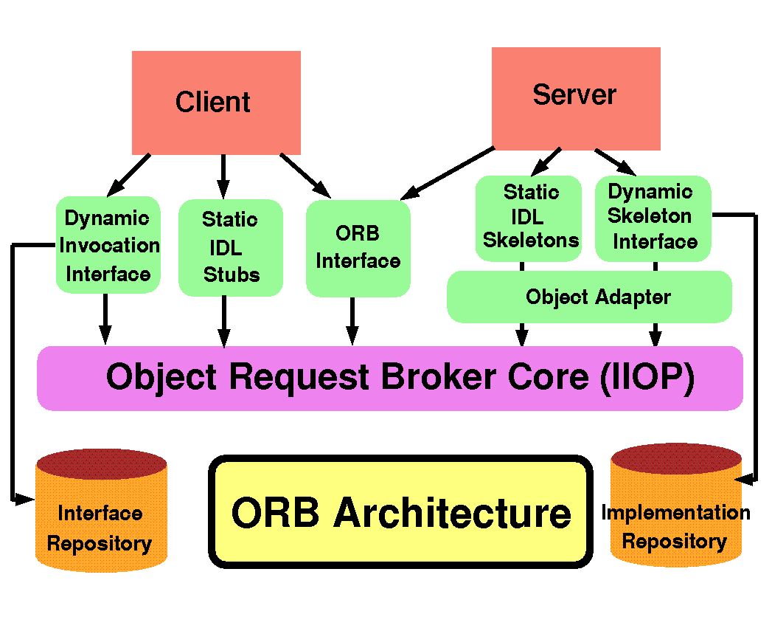

Thin Client Computing

- A thin client is a lightweight computer that is purposely built for remoting into a server (typically desktop virtualization resources).
- It depends heavily on another computer (its server) to fulfill its computational roles.
  - This is different from the traditional desktop PC (fat client), which is a computer designed to take on these roles by itself.
- The specific roles assumed by the server may vary, from hosting a shared set of virtualized applications, a shared desktop stack or virtual desktop, to data processing and file storage on the client or users behalf.
- Thin clients occur as components of a broader computing infrastructure,
- The server-side infrastructure makes use of cloud computing software such as applicationvirtualization, hosted shared desktop (HSD) or desktop virtualization (VDI).
- The benefits of centralization are hardware resource optimization, reduced software maintenance, and improved security.

Thin client hardware:

Thin client hardware generally consists of a computer terminal which provides I/O for a keyboard, mouse, monitor, jacks for sound peripherals, and open ports for USB devices, e.g. printer, flash drive, web cam, card reader, smartphone, etc.

Some thin clients include legacy serial and/or parallel ports to support older devices such as receipt printers, scales, time clocks, etc.

Thin client software typically consists of a GUI (graphical user interface), cloud access agents (e.g. RDP, ICA, PCoIP), a local web browser, terminal emulations (in some cases), and a basic set of local utilities.

Thin Client Platform / environment Characteristics

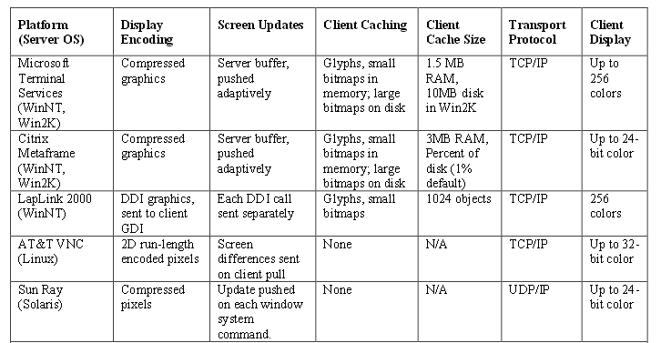

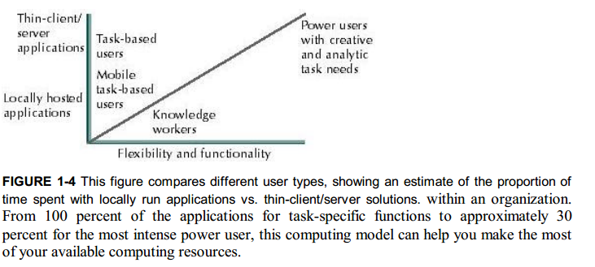

User Scenarios:

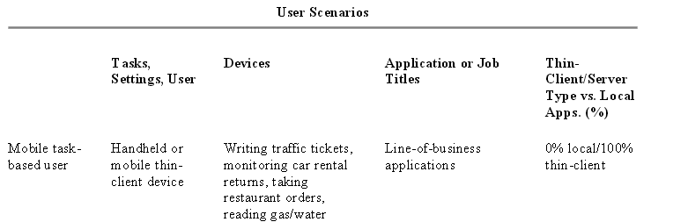

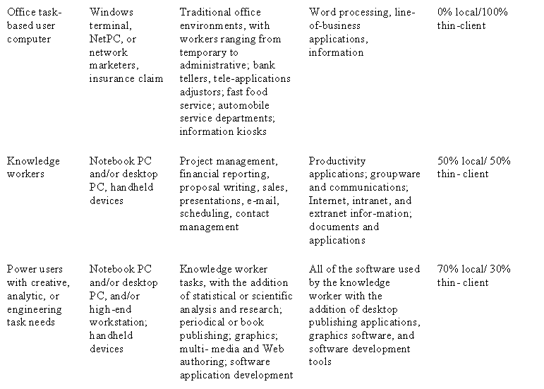

Self study: thin client. Pdf (Management and Scalability, Access,Performance, Security, and Total Cost of Ownership)

